How to expand the wireless coverage by Wireless Bridges?
Product line: wireless question category: function config

You need 2 devices at least to support Wireless Bridge. Here we use W300D and W308R as examples to show how to make a wireless bridge.

The connection topology is as below:
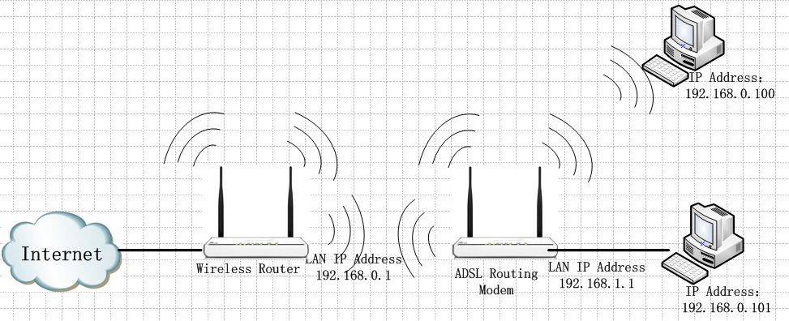

The steps are as follows:
I. The Settings on W308R:
1.Login to the web page of W308R via http://192.168.0.1

Please “Enter” and go into the page below, then click Advanced Settings

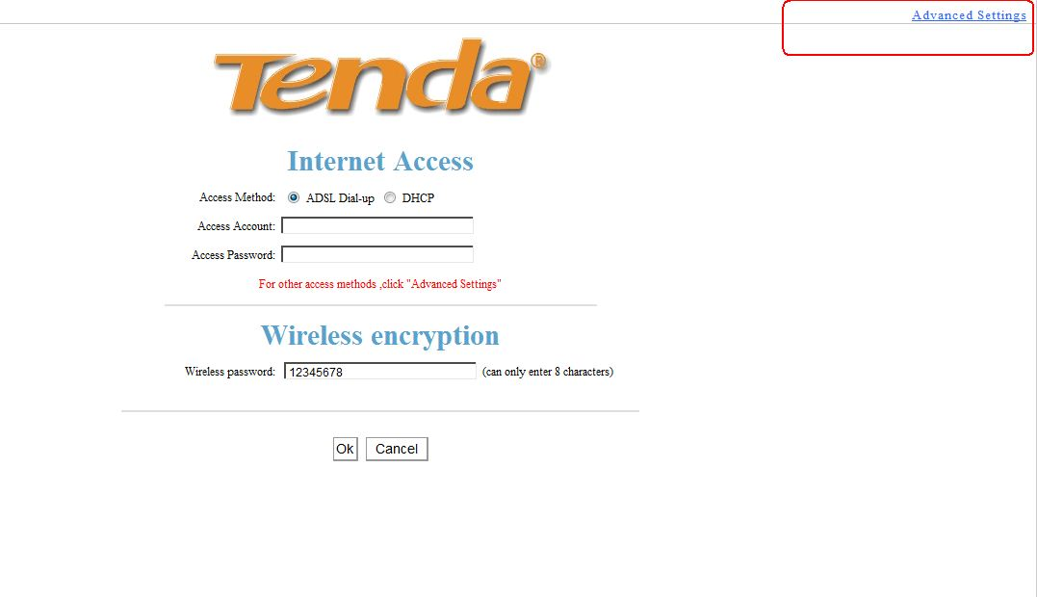
2.Click Wireless Settings, then in the Wireless Basic settings page,please change SSID for other name(for example:AAAW300D),select channel to channel 6,and then chick on Apply
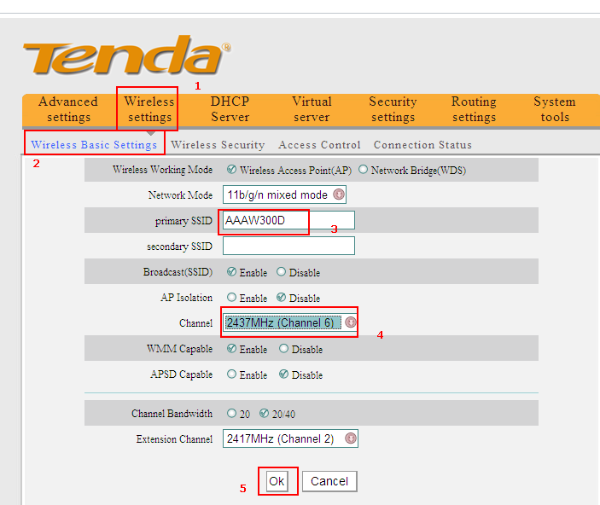
2 Click Wireless Security under Wireless Settings, and do the security settings as the following picture.
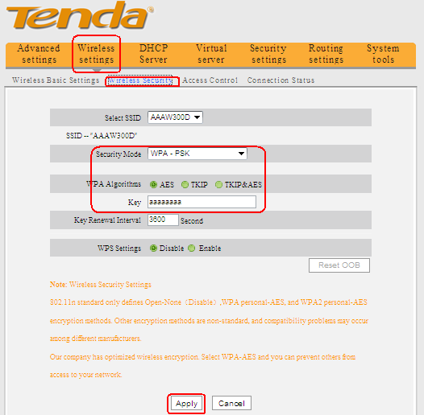
II. The settings on the W300D:
- Login to the management page of the first W300D(The login IP Address is 192.168.1.1). Click Advanced Settings to go to the main management page.

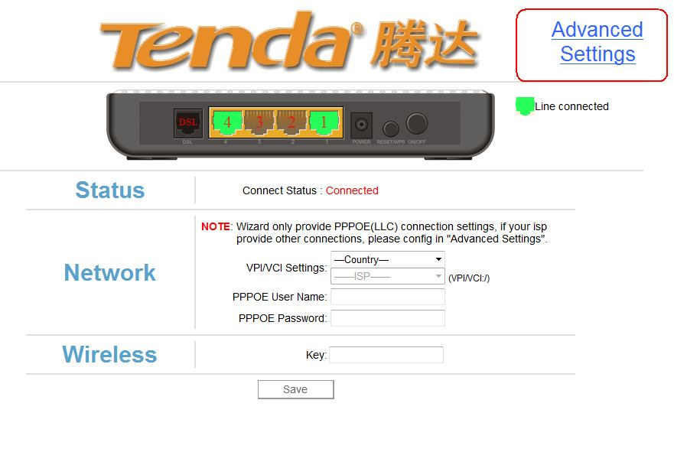

- Click on Wireless->Basic to configure the basic parameters for the W300D.
Note: the SSID , Channel should be the same with the uplink router.

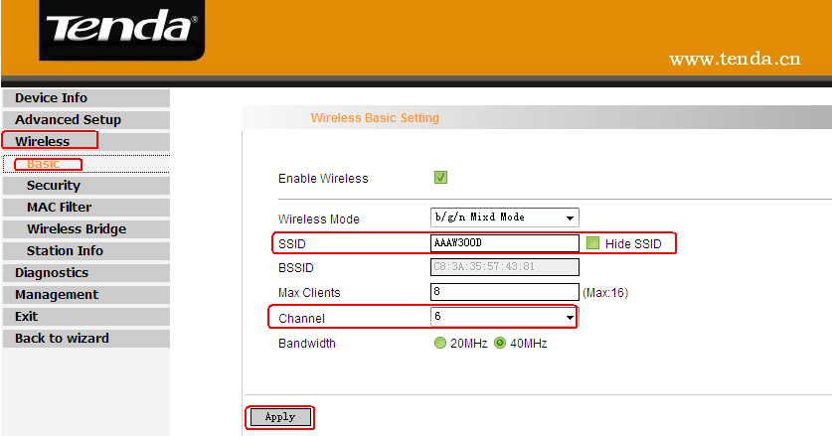
- Click on Wireless->Security to configure the security settings as the following picture.

Note: the network Authentication , algorithms and password should be the same with the uplink router.
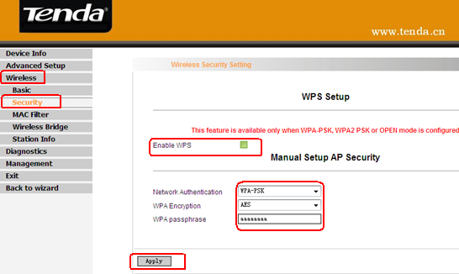
- Click on Wireless Bridge, and then do the settings as the following picture.
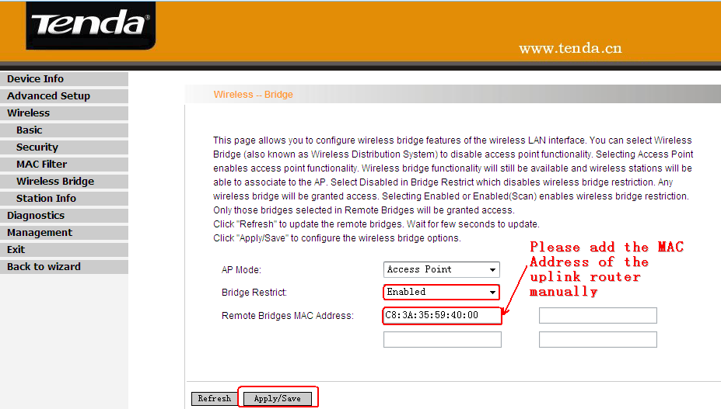
- Please disable the DHCP on this router.
Click Advanced Setup->DHCP Settings. In the page please choose Disable DHCP Server and click on Apply/Save.
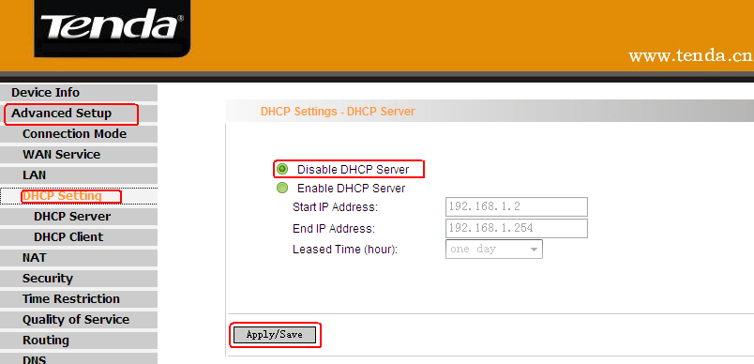
III、Please connect your computer to tenda W308R router ,go back to tenda W308R router manage page(192.168.0.1) to add the MAC Address of W300D, please do the settings as the following picture.
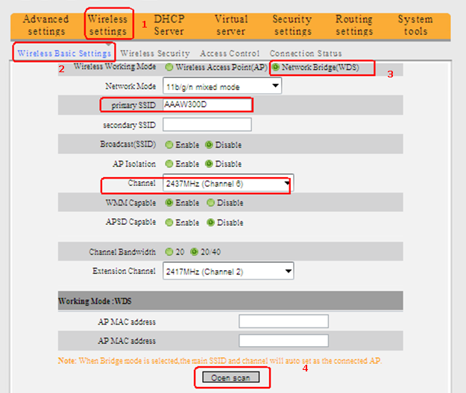
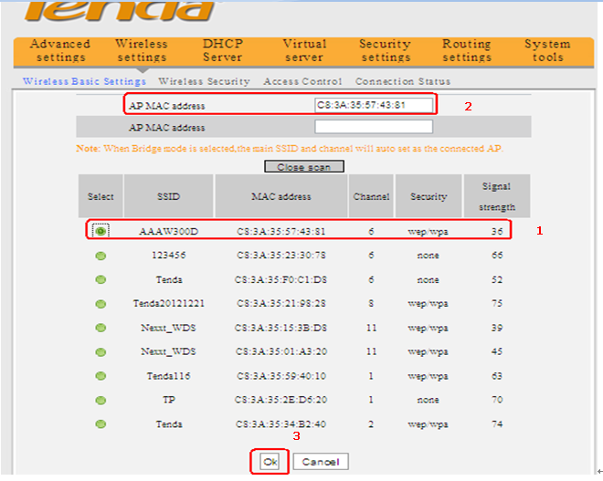
IV、please reboot W308R and W300D.
After the settings, computers connected to the W300D will obtain IP address from the W308R and share the Internet.

